User Experience Evaluation Reporting the usability evaluation of a Hi-Fi prototype of Ideas Gym

Marina Zhuravleva, Zhenyu Wang

Evaluating User Experience

Tallinn University

April 30, 2021

Abstract

The aim of the following report is to see whether participants are satisfied with the improvements we have made by then and to find out usability issues that are left.

The target group of the study involved the following factors: 1) no gender limitations; 2) occupations are students, teachers, students’ parents or brothers and sisters; 3) 18- 45 years old; 4) active internet users; 5) have interest in learning STEM courses online; 6) have bought online courses or used them for free, preferably STEM courses.

This research used self-assessment on first impressions (Five Second Testing), emotional reactions (Geneva Emotion Wheel) and pragmatic measurements (Task Success and Severity Ratings).

The results show that there’s no issues so serious that users’ performances were impeded, but users still reported some common issues which confused or upset them.

1 Introduction

Ideas Gym, an online STEM course platform, is provided by an Egyptian company. Users of this online learning hub use search engines to look for courses or companies they want to learn, and either add some courses to the cart and go to check-out, or contact a company presented in the hub after browsing. Ideas Gym is currently aiming at expanding into the Estonian market in particular and the European market in general.

By now we have upgraded our low-fidelity prototype to a functional one through HTML, CSS, and JavaScript. Significant improvements we have made include:

* Specific search options in dropdown menus;
* Search functionality;
* The information architecture;
* Serious images for goods (courses);

This report includes three sections. The first section states the background and the objective of this usability testing, the second section introduces the design procedure, and the final section presents the results of this testing and the analysis.

2 The Objective of Evaluation

First, in the light of Jennifer’s review (2000), the behaviours of Idea Gym’s users are closely related to a model of the consumer buying process which consists of problem recognition, information search, information evaluation, decision and post-purchase evaluation. Jennifer () also argued that the imprecision of users’ search outputs is attributed to less information which users access and bring to the search process. Accordingly, We have predicted some questions regarding the second process of this model, and plan to see if these questions lead to negative impacts on user experience.

* How do participants manage to understand specific search options and find what they are looking for?
* Are participants feeling satisfied with search functionality? How do participants evaluate the usability of the search engine?

Second, the goal of Ideas Gym is not only to provide users in Estonia with convenient search engines, clear navigation and courses of good quality, but also to make them think of Ideas Gym first after they have problem recognition and want to look for a platform. Hence, we also consider several questions about users’ perception of the system.

* How do participants feel about information architecture when searching for information about course producers such as teachers and companies?
* Have participants felt satisfied with the layout of our prototype? How do they evaluate the use of colourful backgrounds and patterns this time?

The object of the usability testing is to see whether participants are satisfied with the improvements we have made by then and to find out usability issues that are left. Through collecting data and doing analysis, we hope to figure out solutions for further improvements so as to meet our client’s requirements.

3 Design Procedure

3.1 Procedure

The evaluation was undergone online. Video was captured of the on-screen interactions. The test procedure consisted of:

* planning: recruiting participants, determining features to test, creating tasks;
* before test preparation: signing of the consent form;
* 7 tasks: evaluating first impression, usability and emotions
* gathering data
* doing analysis and discussion

3.2 Tools and Methods

Based on questions and a model of the consumer buying process previously mentioned, we tried to derive a series of tasks users need to complete from the possible behaviours within the consumer buying process.

* Imagine you were playing a role and were looking for a course you want on an online STEM hub (the scenario is related to participants’ backgrounds). Go to browse the whole site and find a course of 50 euros for beginners.
* Read the description of the course you are required to choose, and find the access to company’s page and read information regarding that company;
* Learn information about teachers who are in charge of that course;
* Add the course to your shopping cart, and go to check-out;

The first aim of our usability testing is to see whether participants can complete a transaction, and we also hope to observe that the navigation or information architecture in our prototype does help users find what they want quickly and easily, so the method we choose is task success metrics.

Second, since we have made some changes to improve our low-fidelity prototype, we are in need to identify major usability issues and to make follow-up improvements so as to meet client’s requirements, severity ratings may be the most appropriate for problem discovery.

Third, in order to gain data regarding participants’ emotions and feelings, self-reported tools are needed. This time we choose to use five second tests before participants perform behaviours and use Geneva Emotion Wheel after they complete all the tasks.

The list below presents all tools and methods used:

1. Five second tests

* Materials:

We will create a five second test on this site: <https://fivesecondtest.com/>

* What are five second tests:

Five second tests are a method of user research that help you measure what information users take away and what impressions they get within the first five seconds of viewing a design.

* When and how to use:

Five second tests are used for optimising the clarity of our design before participants perform follow-up tasks. Participants are given five seconds to view a design and answer some simple questions.

Because five seconds is too short to see clear what happened, we finally set seven seconds.

We designed three questions for participants to answer:

1. What have you seen in this screenshot? Is it a site for e-commerce? If not, what is the use of this site?
2. What do you think of the layout of this site?
3. What is the first step you want to take when entering this site?
4. Task success

* Materials:

Observation through share screen, questions for users and a bar chart in Excel

* What is task success:

Task success is the most widely used performance metric. It measures how effectively users are able to complete a given set of taske. Two different types of task success are reviewed: binary success and levels of success. This time, we choose to measure levels of success

* When and how to use:

We observe participants try to complete task 2, task 3, task 4, task 5, and task 6 through the share screen and we ask them questions after each task. Participants are allowed to think aloud, and ask questions for help during performing the tasks.

A four-point scoring method is used for each task:

1 = No problem. The user completed the task successfully without any difficulty or inefficiency;

2 = Minor problem. The user completed the task successfully but took a slight detour. He made one or two small mistakes but recovered quickly and was successfully;

3 = Major problem. The user completed the task successfully but had major problems. She struggled and took a major detour in her eventual successful completion of the task;

4 = Failure /gave up. The user provided the wrong answer or gave up before completing the task or the moderator moved on to the next task before successful completion;

1. Severity ratings

* Materials:

Observation through share screen, questions for users and a bar chart in Excel

* What is severity ratings:

Severity ratings are a useful way to deal with the usability issues which mildly annoy users and the usability issues which lead to wrong decisions or missed data. Generally, severity ratings can be classified with two types: severity ratings based on the user experience and severity ratings based on a combination of factors.

* When and how to use:

Usability issues are based on behaviour in using a product, so we use severity ratings when participants perform task 2, task 3, task 4, task 5, and task 6. We focus on possible issues through observations of participants’ behaviours and face expressions, their questions for assistance and their answers to our questions after each task:

We choose a three level severity rating system based on the user experience:

Low: Any issue that annoys or frustrates participants but does not play a role in task failure

Medium: Any issue that contributes to significant task difficulty but does not cause task failure

High: any issue that leads directly to task failure

1. Geneva Emotion Wheel

* Materials:

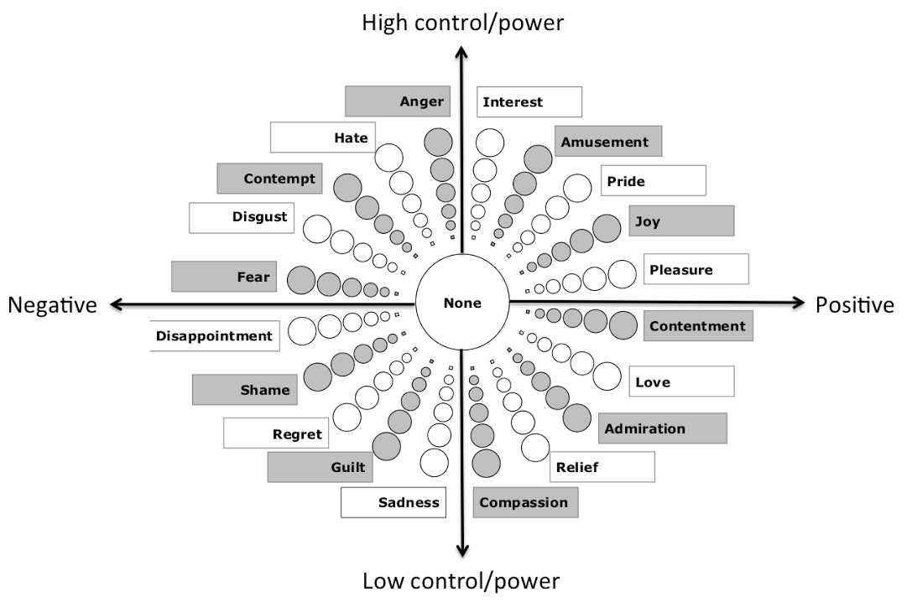

* What is Geneva Emotion Wheel:

Geneva Emotion Wheel is an ultimate instrument used in usability testing. The emotion families are arranged in a wheel shape with the axes being defined by two dimensions of emotional experience. Geneva Emotion Wheel is aimed to obtain self-report of felt emotions elicited by events or objects

* When and how to use:

After participants perform all tasks. Participants are required to choose the emotion they were feeling when performing tasks, by choosing intensities for a single emotion or a blend of several emotions out of twenty distinct emotion families.

3.3 Apparatus and Materials

All participants were required to use their laptops with microphone opened and screen shared throughout the evaluation. There are two tools for self-reported metrics: one is the link to Five Second Testing, and another is an image of Geneva Emotion Wheel.

Basic information about the whole evaluation process and instructions of how to complete Five Second Testing and use the Geneva Emotion Wheel were attached to mails which we sent to participants in advance.

3.4 Participants

Before conducting usability testing, we determine the test audience, and start recruiting immediately.

Because of pandemic restrictions, we are hardly able to contact Estonian locals in a face-to-face way, and recruiting representatives of the target group is also challenging. Instead, we changed the criteria to screen target participants, and took into account people who are able to use English as their second language.

We determined the following criteria for the respondents:

* Men or women;
* Potential users including students, teachers, students’ parents or brothers and sisters;
* 18- 45 years old;
* Active internet users;
* Have interest in learning STEM courses online;
* Have bought online courses or used them for free, preferably STEM courses;

and we managed to recruit seven participants. Four students come from China, two of them have brothers or sisters; one teacher who used to live and work in the US has work experience of teaching international students Chinese; one student come from China, but has lived and studied in the US for nine years; an American English teacher now works at an international Kindergarten in China.

4 Results and Discussion

Part 1:

In completing the Five Second Test, almost all participants said that even seven seconds were not enough to see clear what the screenshot showed. Only one participant answered that it is a site for online STEM courses, because she had participated in the evaluation of our low-fidelity prototype. The other participants failed to see through the purpose of the site shown in the screenshot, though they had grasped some visual information.

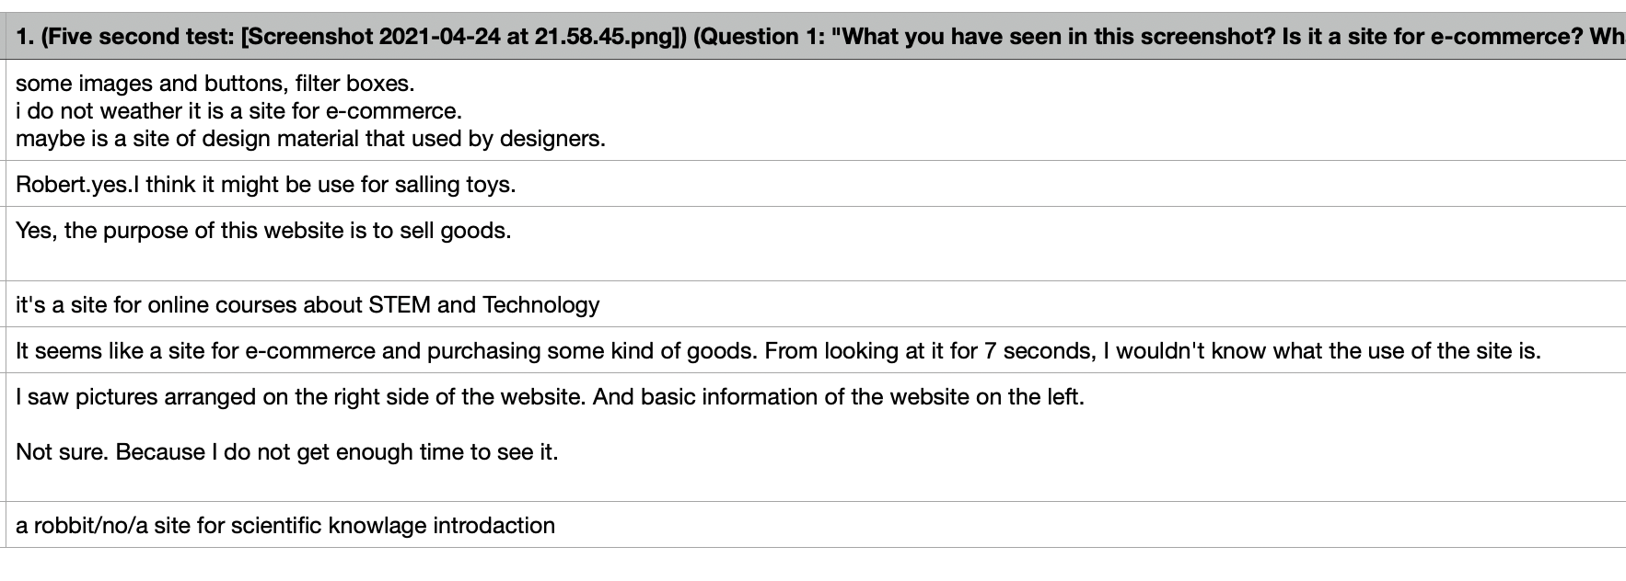

As for the layout shown in the screenshot, participants thought of it as clear and easy to follow. Although they failed to understand the purpose of the site shown in the screenshot, most participants asserted that they would continue to explore this page when entering the site, through clicking the images or translation button, while only one participant didn’t know what to do when entering the site.

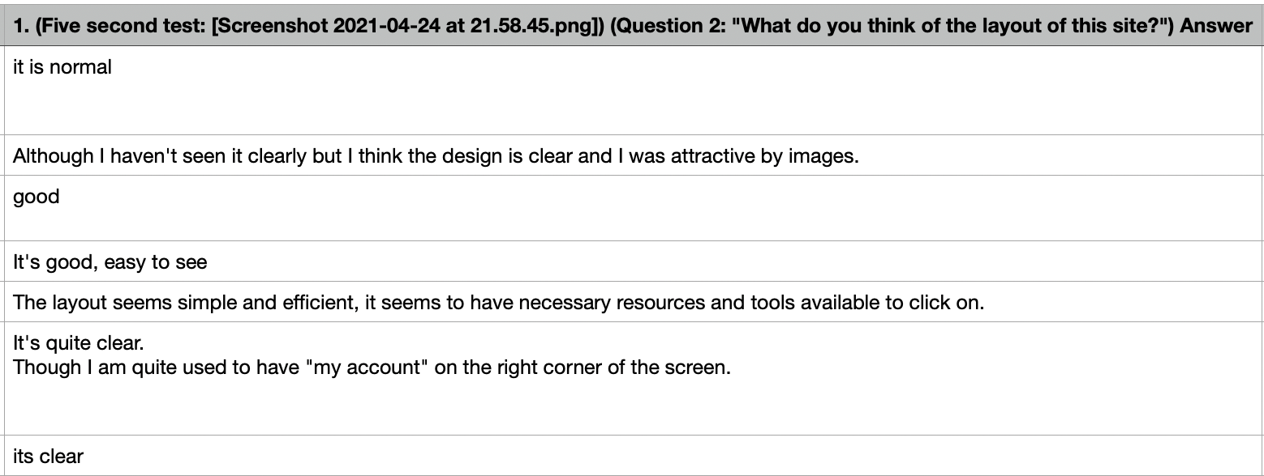

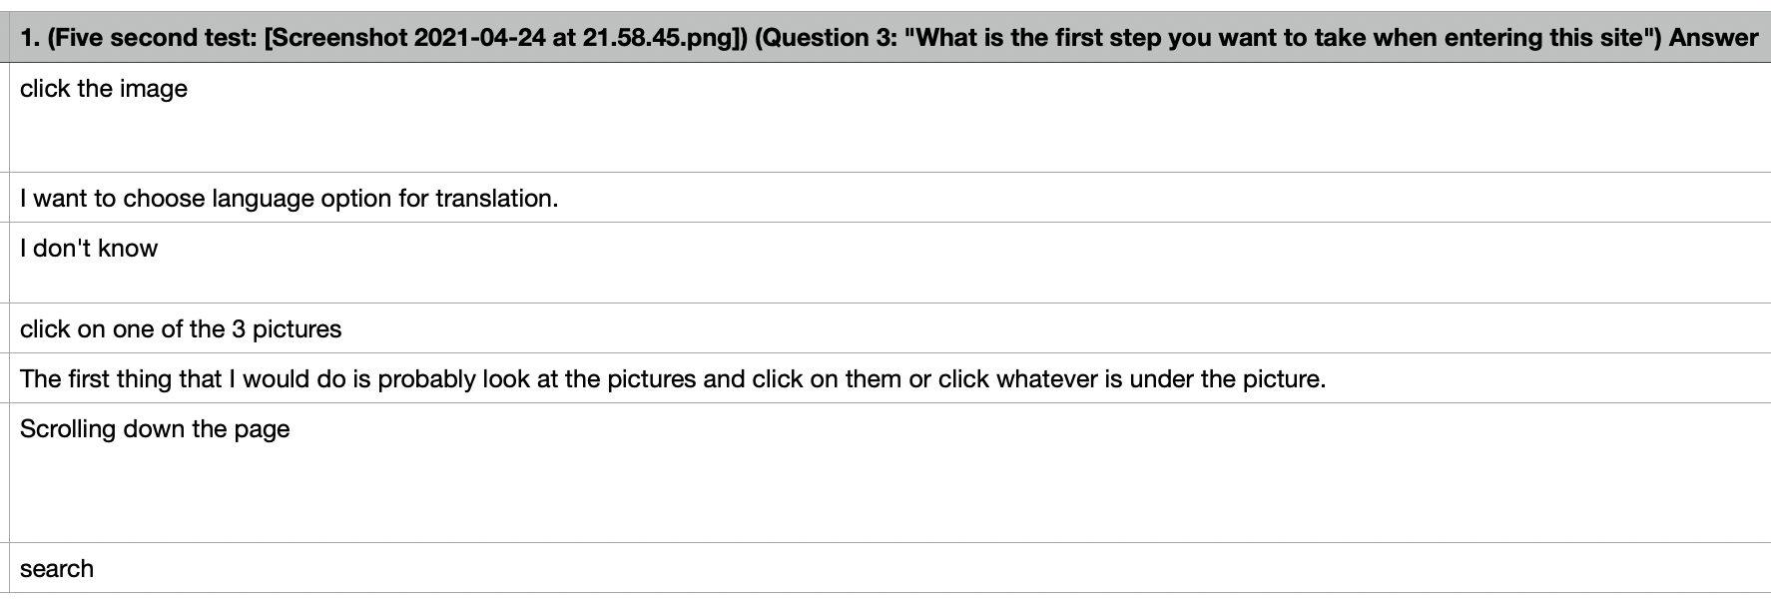

To sum up, Participants had a good impression of the layout, and value it as clear and simple. However, their perceptions of the possible purpose of the site were not precise since seven seconds were still short. Things to consider can be, for example, how to shorten the time of gaining the purpose of the site at first look, and whether we need a broader picture to test more features which have not been tested yet.

Part 2:

As the first bar chart below shows, only one participant managed to complete all tasks without being disturbed by issues, while the other participants were confronted with issues in task 2 and task 4.

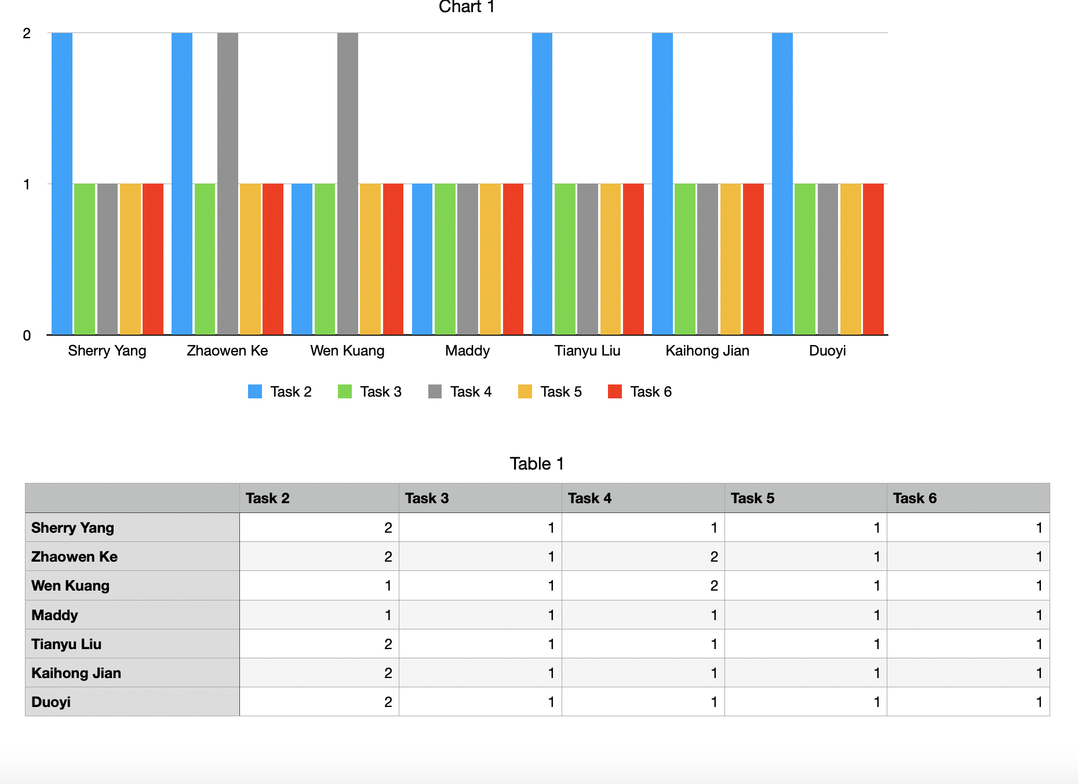

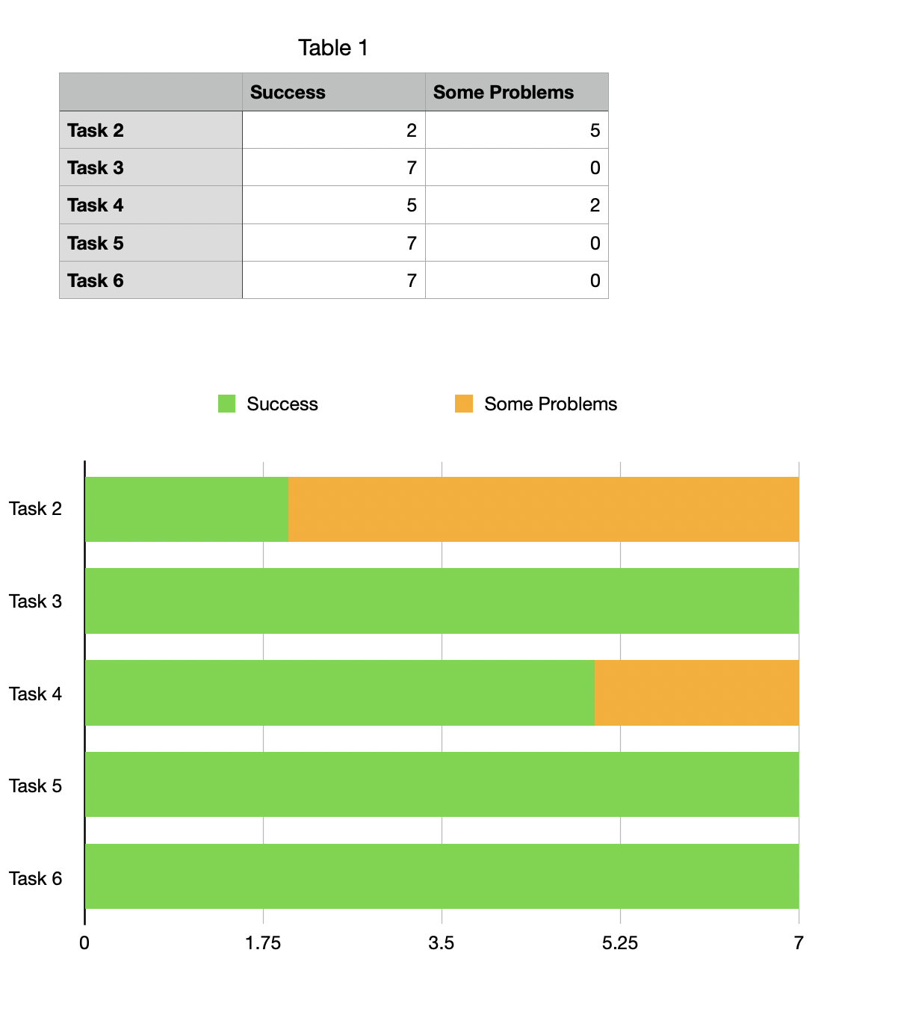

As the second bar chart shows, five participants faced issues in trying to complete task 2. Based on transcriptions, we noticed that participants failed to understand the use of ‘mentoring’ option, though all of them found it easy to use the search engine. Task 2 requires participants to find a course of 50 euros for beginners, and the right way is to set numbers inside the ‘price’ option, and set the ‘mentoring’ option as ‘YES’. They knew the meaning of mentoring, but felt it is hard to establish a connection between ‘mentoring’ and ‘beginner’. It was because there was only one course for beginners whose price is within 50 euros that they completed task 2 without setting a ‘mentoring’ option. Hence, had there been more courses of 50 euros, participants would have felt confused.

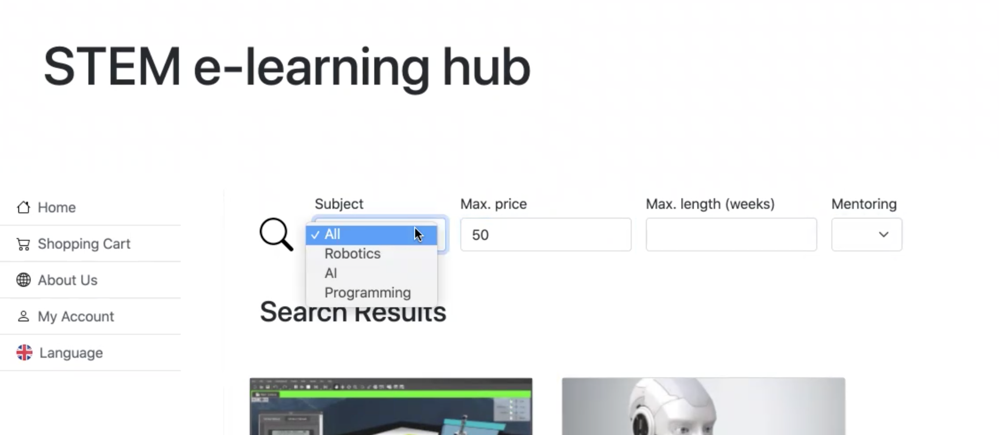

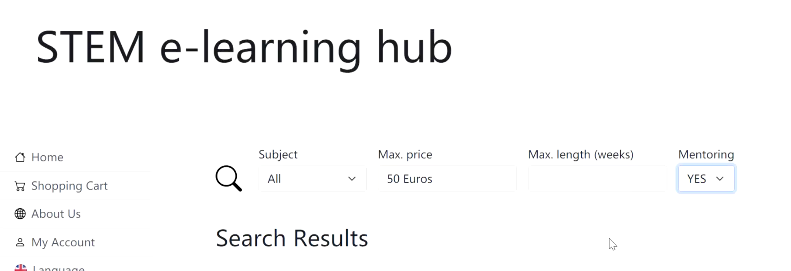

Interestingly, one participant also questioned us why not add a currency unit next to the text ‘Max. price’, because she tended to text one more word ‘euros’ after the number. There might be fewer internet users to input one more unit after price, but in fact, most e-shopping platforms do add such a currency unit, and this unit changes once the users set the user’s region. For example, the price setting on Amazon.

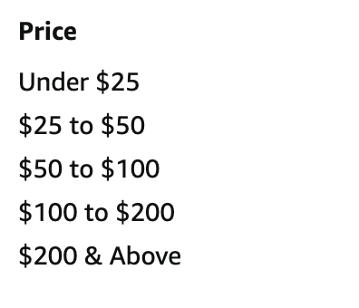

There were also two participants faced issues in trying to complete task 4. Task 4 requires participants to enter the page of the company, and go back to the page of this course after browsing. No participant failed. According to transcription, we discovered two reasons for their success. Some participants noticed the change of cursor, and clicked the company logo, while others just had a trial to see what they could click and whether there is an access to the company page. Almost all participants reported that it was not hard for any active internet users to realise that they should click the company logo, but they did hope to see a more obvious hint or signal to know what can access to another page, and it could be an underline, or highlighted words, or a button.



Overall, the search engine is easy to use, and the navigation is clear. However, in order to elevate user experience, we should use appropriate terminology to offer direct guidance to users, and so users are able to connect their needs with the information offered on site. Second, we need to consider whether it is necessary to make the navigation to another page more obvious. As stated by participants, active internet users will click something naturally if they notice the change of cursor in moving the cursor around it. However, if users were not familiar with cursor, they would feel confused, and might succeed in searching for something by trial and error. One of criteria to recruit participants is that they should be active internet users, but we should also consider what they will be confronted with and what they will feel if the elderly or someone who knows less about computers and the internet, and figure out solutions. Third, although Ideas Gym is an online learning hub, its search engine still has some features of e-shopping platforms. Accordingly, the subtle similarities among e-shopping platforms call for more attention, though they might not impede users’ performance, for example, the currency unit.

Part 3:

Through observations of participants’ behaviours and face expressions, their questions for assistance and their answers to our questions after each task, we derived two main issues: misinterpretation of search options, unclear navigation to another page, and weird layout. These three issues made participants diverge from the right way we were expected, or made them upset, but did not distract them from tasks or cause failure. Hence, we determined a three-level severity ratings:

* Low severity:

1. unclear navigation to another page;
2. weird layout;

* Medium severity: misinterpretation of search options
* High severity: none

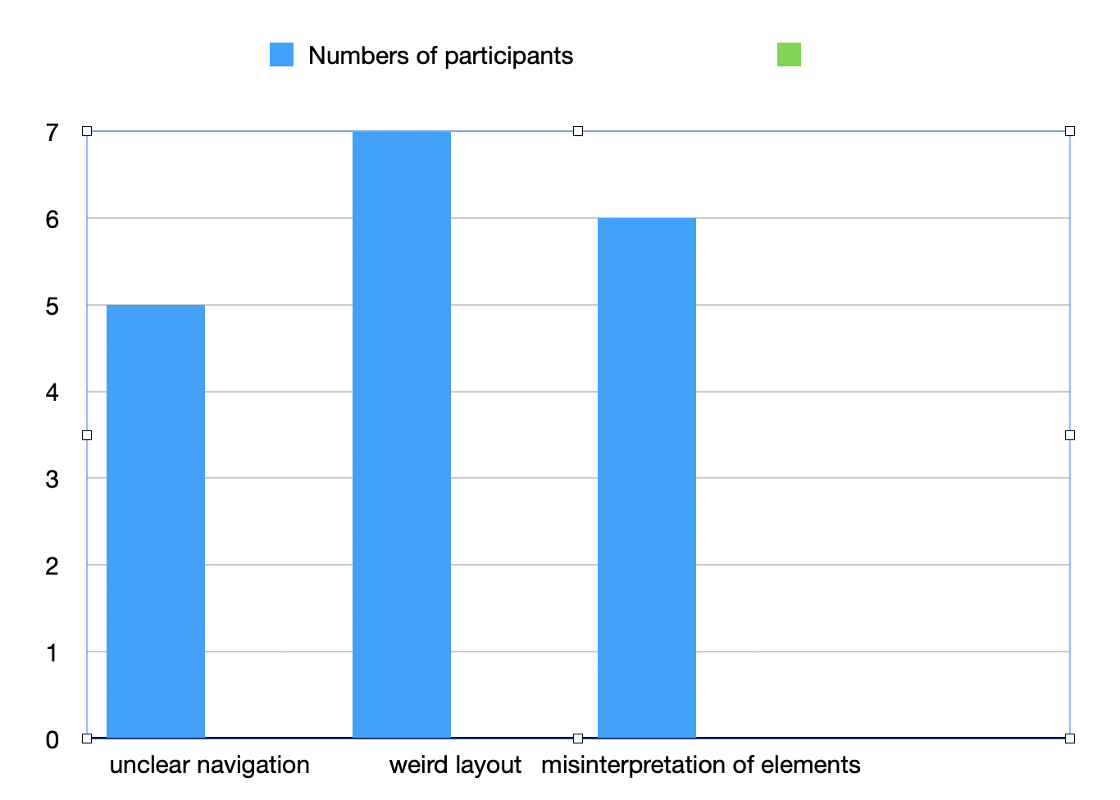

Part 4:

The results of the Geneva Emotion Wheel show a division of emotion feedback. Accordingly, we could divide six participants into two groups, representing two opposite responses:

Group 1:

Sherry Yang: neutral, indifferent, not complicated;

Duoyi: neutral, less attractive;

Kaihong Jian: just a normal shopping experience;

Group 2:

Maddy: interested, very contented;

Wen Kuang: clear and convenient, satisfied, hope to see more improvements;

Tianyu Liu: less attractive, but much contentment;

In addition, only one participant who detoured to complete task 2 and task 4 value his experience as regret, one adjective shown in the wheel, and inconvenient, his own word.

First, we can conclude that negative emotions seldom arise, and they might be easily triggered by some issues regarding layout design which will not impede user’s performance but upset users, or individual performance which is quite different from majority.

Second, we tend to believe that our prototype just offered users a normal online course shopping experience because search tools, layout design, and information architecture are simple and clear. However, it is hard to conclude that they were all satisfied with this prototype. Only one participant who said she was satisfied also thought of our prototype interesting, while the other two participants did not have any other positive responses or explain why they felt satisfied.

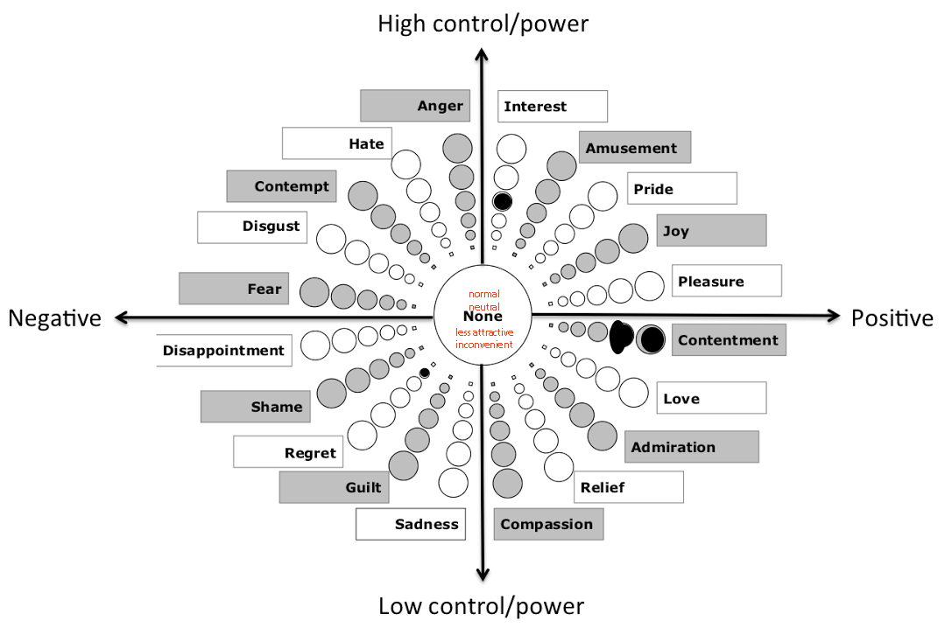

5 Conclusion

There are no serious issues that participants’ performances were impeded, and participants all felt that the search engine was easy to use and they were able to complete a transaction with the information offered. However, being satisfied with the pragmatic quality of our prototype doesn’t mean participants felt satisfied with the whole purchase experience. In fact, their emotional responses were just neutral; that is, they held detached attitudes and hoped to see more improvements. To a certain degree, they misunderstood terminology used in the search engine, and were also confused and upset by the layout of the company page, but overall, their satisfaction with functionality of our prototype was not overshadowed by these tiny negative feelings.

We have also tried to make some improvements after this evaluation. Three things we have done:

* adding a new filter option ‘Course level’;

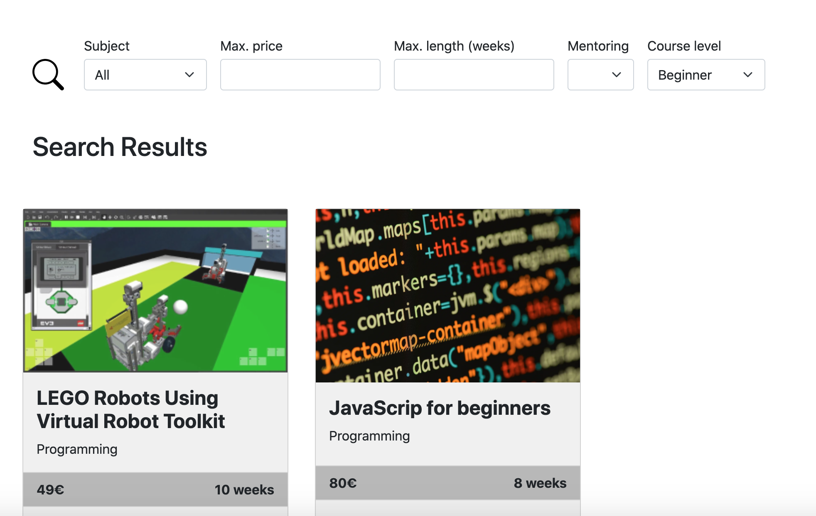

* adding a more obvious navigation, underlined ‘Have a visit’ to guide users to find company page;

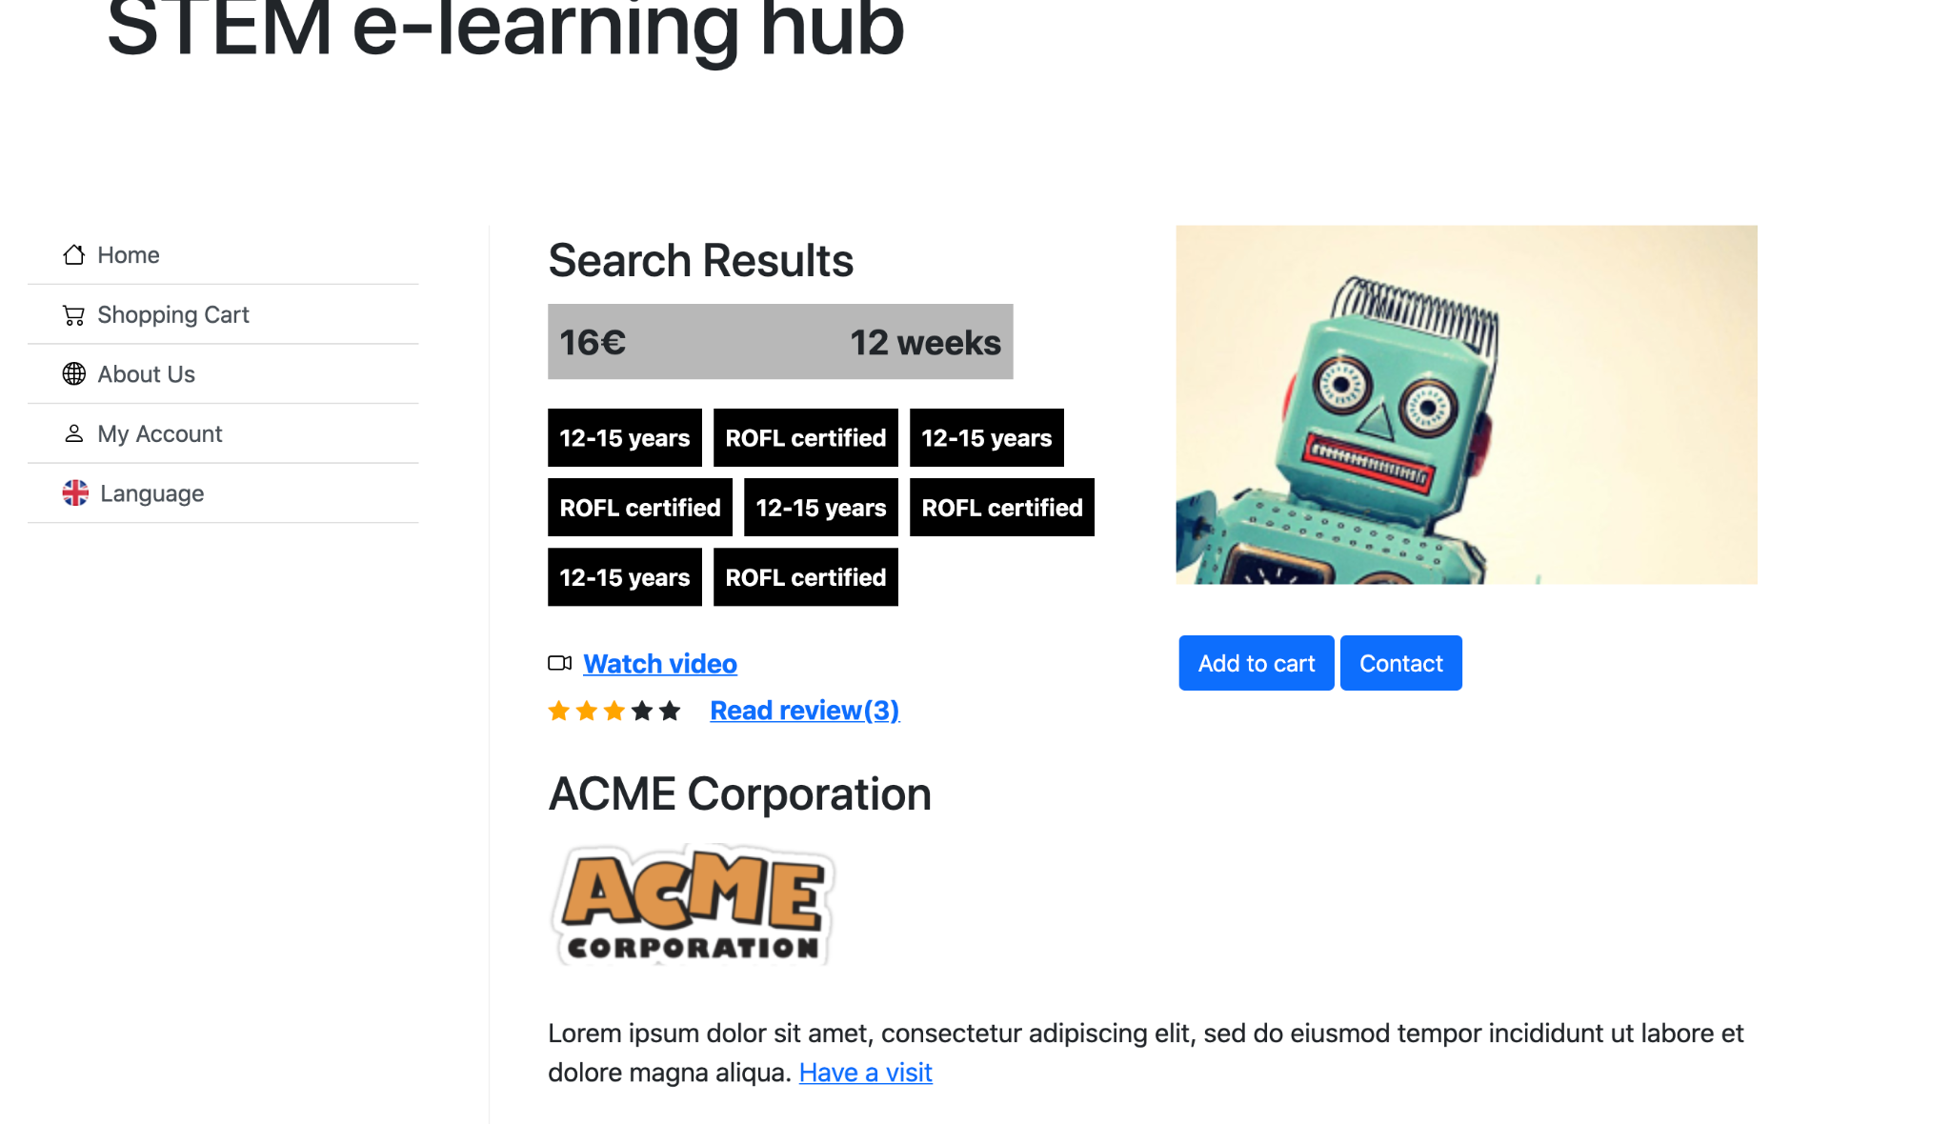

* adding ‘follow’ button and a ‘contact’ button below the logo on the company page;



* changing the layout of company page: enlarging the carousel, introducing company with fewer texts and more images in a container;

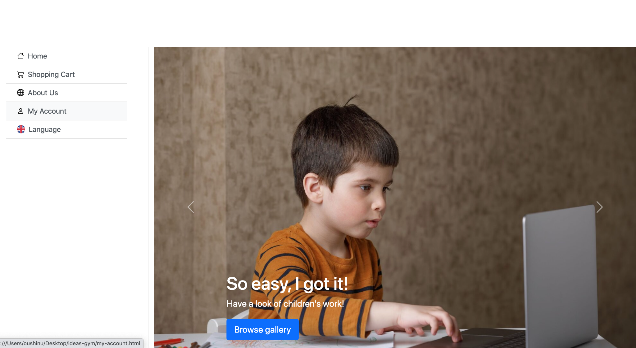

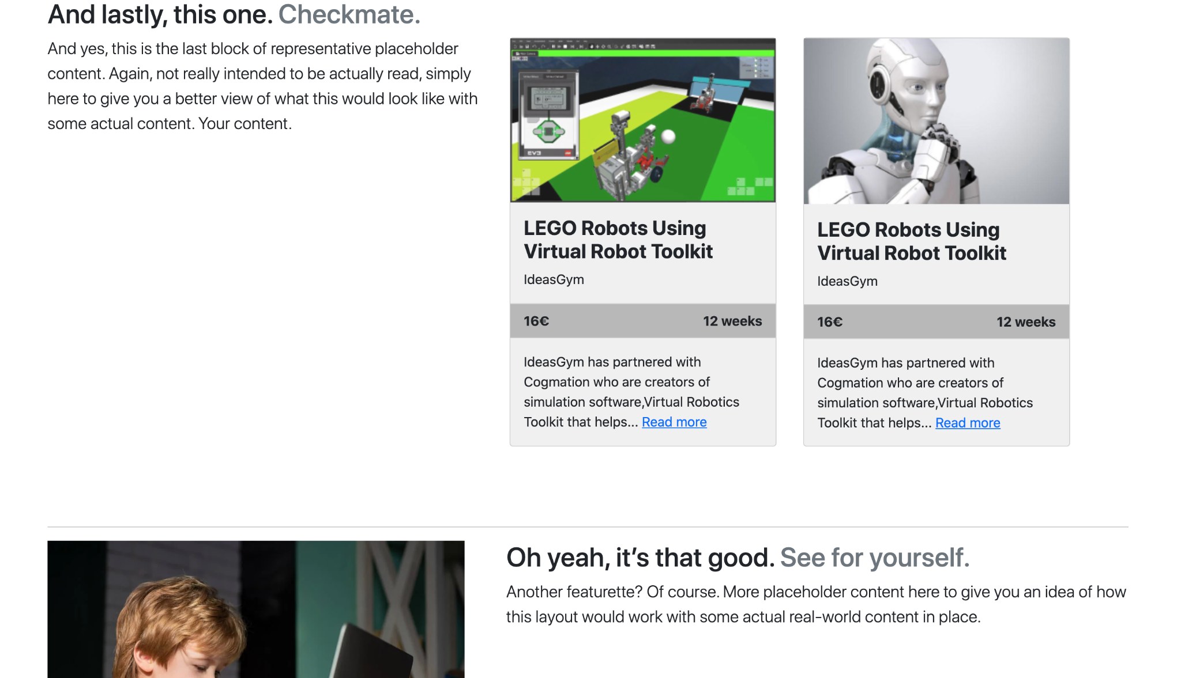

Thus, the further research should focus on what and why subtle changes in interactive design will influence the use of the search engine, and when combining e-shopping and online learning on the same platform, what kinds of common interactive elements and functionality should be left and what kinds of them should be cancelled.

**Reference:**

Jennifer, R. (2000), “Product search in e-shopping: a review and research propositions”, Journal of Consumer Marketing, Vol. 17 Iss 1 pp. 20 - 35 <http://dx.doi.org/10.1108/07363760010309528>

Mike, K. (2003), Observing the User Experience, A Practitioner’s Guide to User Research, Morgan Kaufmann Publishers

Tom, T., & Willi, A. (2008), Measuring the User Experience, Collecting, Analysing, and Presenting Usability Metrics (Interactive Technologies, Morgan Kaufmann Publishers